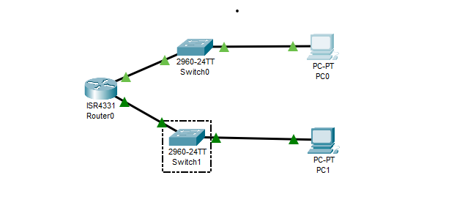

**To use network commands in Packet Tracer:**

* **Select a PC.**
* Go to the **Desktop** tab, and launch the **Command Prompt**

1. **ipconfig**

* The ipconfig command lists all current TCP/IP settings on the device, such as IP addresses, subnet masks, default gateway, and renews DHCP/DNS values when necessary.

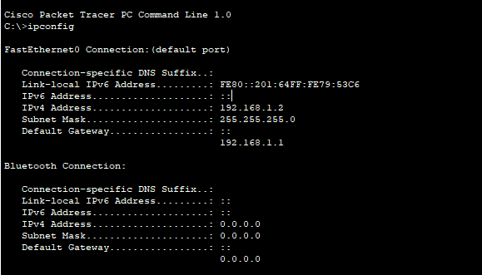

**2. tracert**

* The tracert command reveals the route packets follow to reach a specific destination by using ICMP Echo Requests.

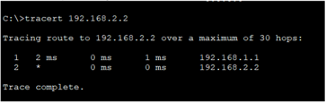

**3. telnet**

* telnet enables interactive remote sessions with other systems through the Telnet protocol.

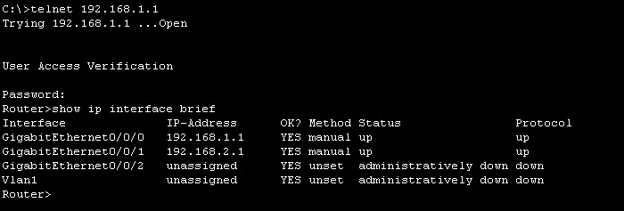

4. **Router Configuration**

* Set the router’s IP address.
* Assign an IP address to the router interface.
* Configure the network address for the router.

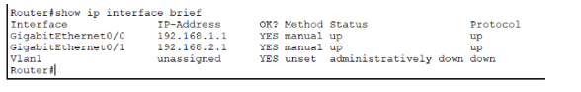

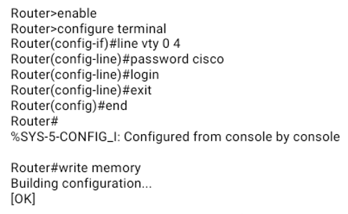

5. **Test Connectivity with Ping**

* From PC, check reachability to another device (e.g., 192.168.2.2):

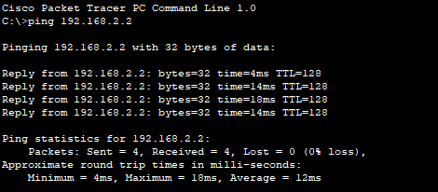

6. **nslookup**

* nslookup <domain>
* This command requests the DNS to provide the IP address for a given domain or the domain for a specific IP
* To use nslookup in Cisco Packet Tracer, confirm that the DNS server is reachable and correctly configured in your network.

